**Declare Constraints/Constraints:**

**It is used to Validate One Property.**

**It is used to restrict/Validate a Property value based on another Property Value ( Dependency Validation)**

**In Declare Constraints, in 1 instance we can add multiple Constraints**

**In Declare Constraints you need to choose function to define the validation ( Compare Functions)**

**Template for Declare Constraints:**

**When something is True  ( Compare Functions/Using Expression builder )**

**Requires that Something else has to be True**

**Else add a Message to Property**

**Req: Validate LName against FName such that both the Values should not be same, If same display error message for LName .**

**1 Instance - we can define multiple Constraints**

**Use Existing Customer Details Section.**

**Create Constraints Rule from Decision Category:**

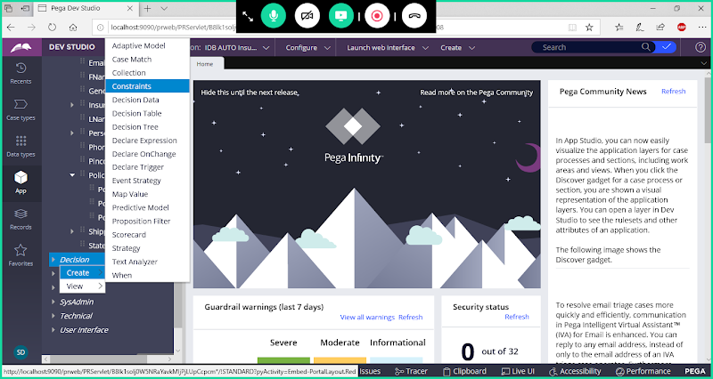

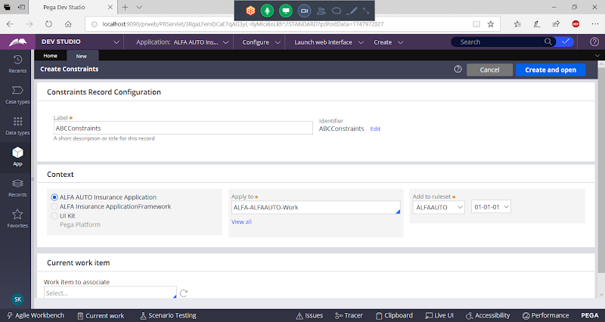

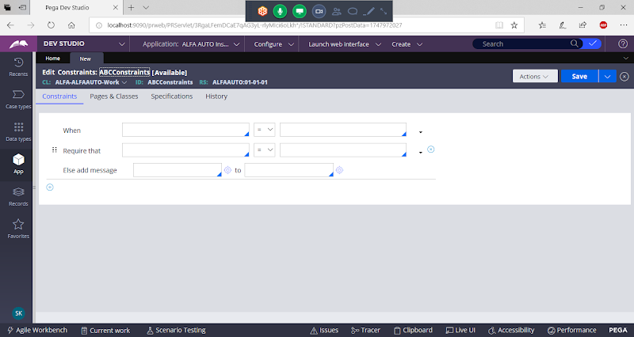

**Choose a function to compare 2 strings:**

**Select Function : First Value  Relation Second Value**

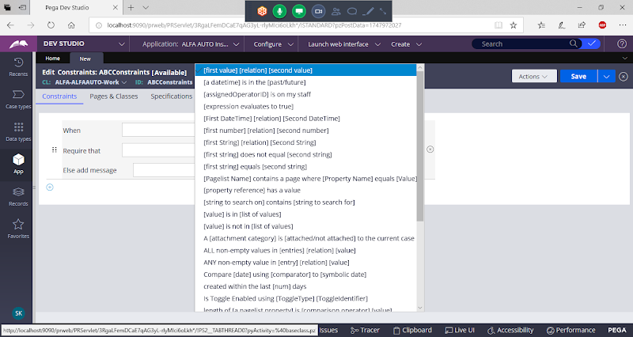

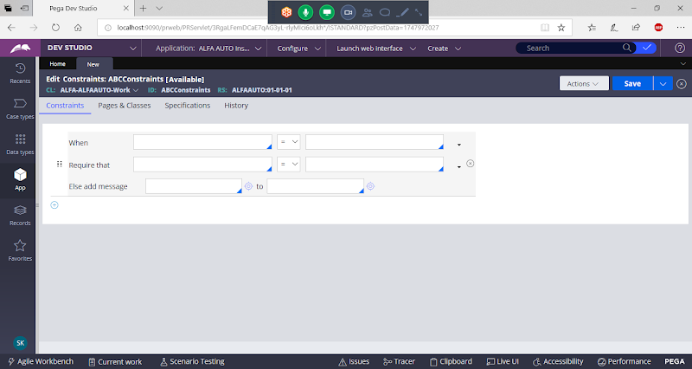

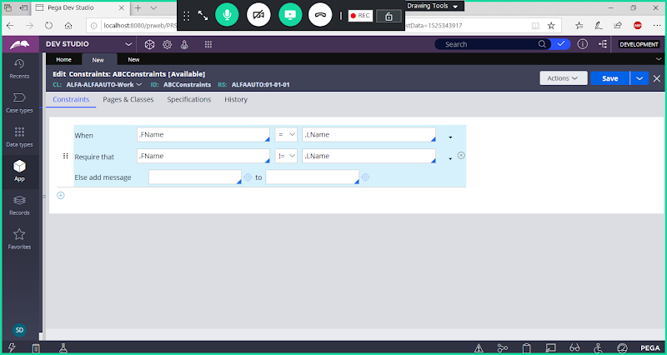

**Add Message Manually**

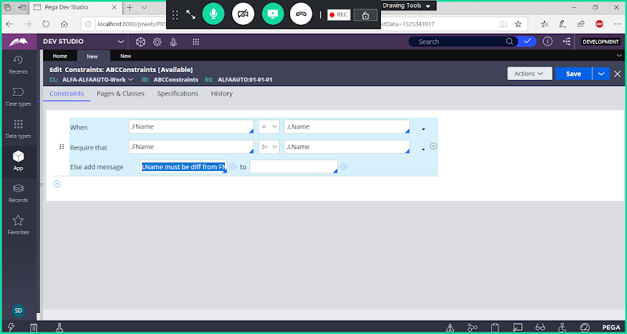

**or Add Error Message using Message Rule:**

**Add Error Message using Message Rule ( Technical Category)**

**Next To add a message click on circle  ( Message Rule will open)**

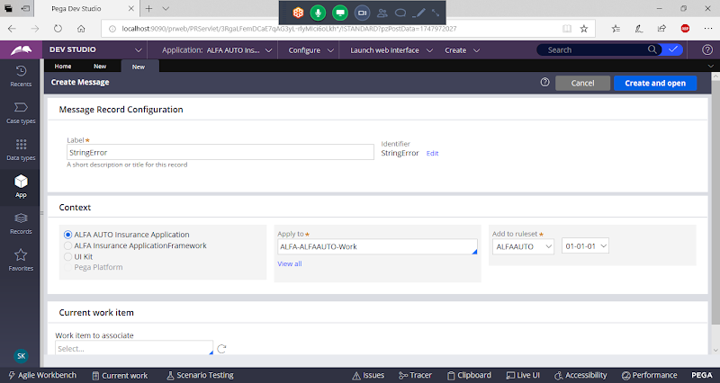

**open**

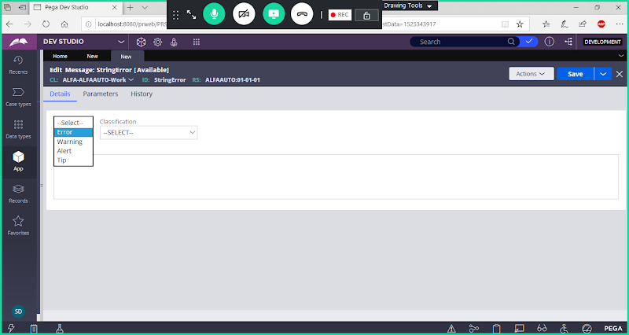

**Select Error**

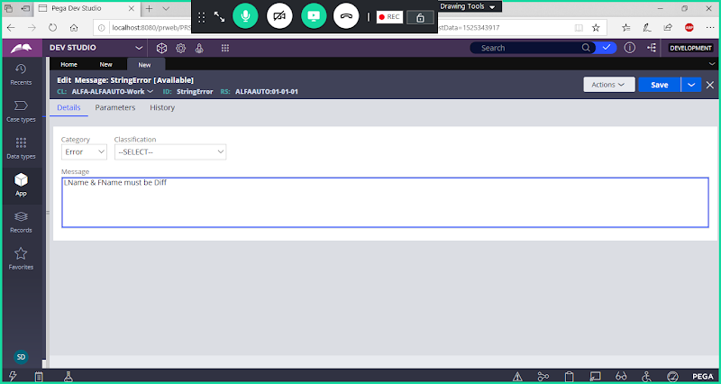

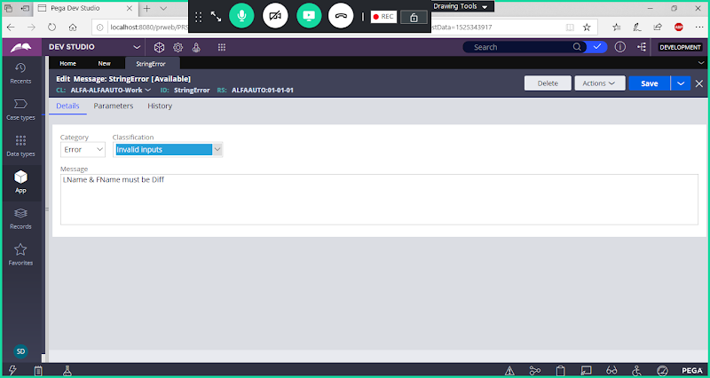

**Save Message Rule**

**Open Constraints & Call Message Rule in the dropdown:**

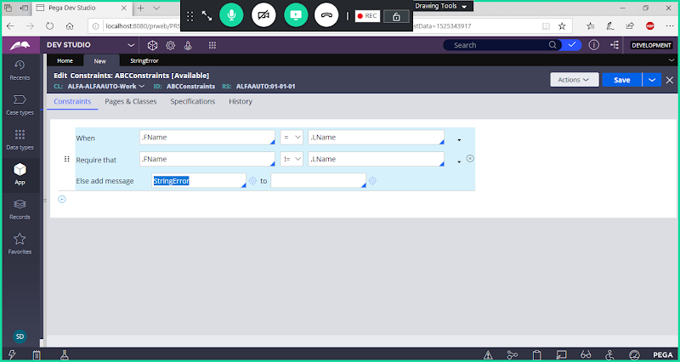

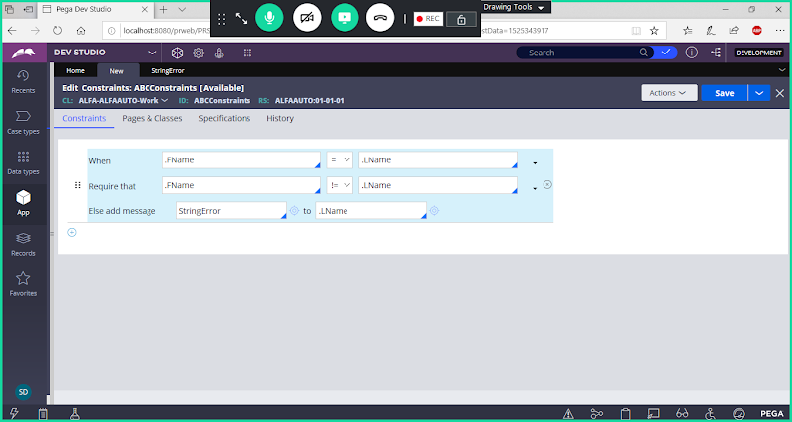

**Save Constraints**

**Now Run Customer Flow:**

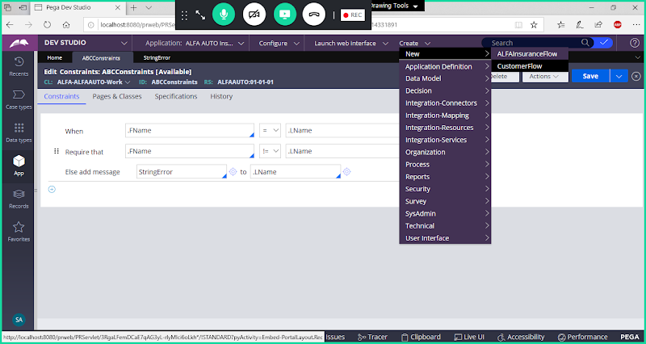

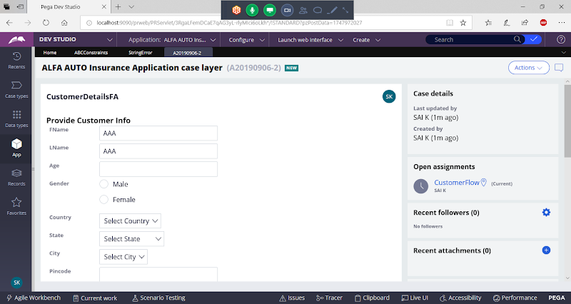

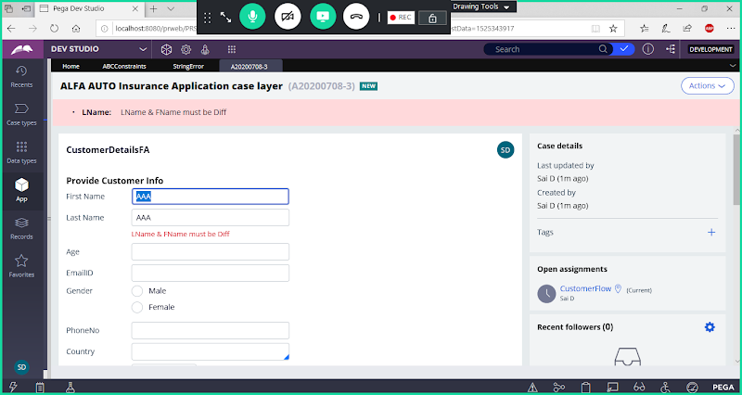

**Try Below Task:**

**Cond1: If Gender = Male/M**

**Age > 21**

**If Less than 21 display error message for Age Property**

**====**

**If Gender = Female/F**

**Age > 18**

**If Less than 18 display error message for Age Property**

**===**

**Open Gender & Update Standard Value Using Table Type ( PromptList)**

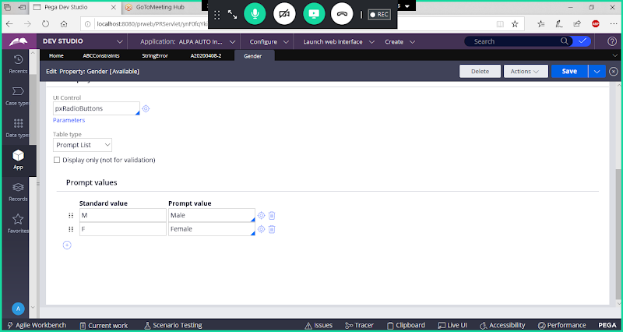

**Open Existing Declare Constraint Rule & Add New Condition:**



